**HELICAL ANTENA DESIGN AND ANALYSIS USING MATLAB**

**Table of Contents**

* **Abstract**
* **Introduction**
* **Software used**
* **Design Specifications**
* **Result and analysis**
* **Conclusion**

**Abstract**

This project focuses on the design and analysis of a helical antenna, utilizing MATLAB for simulation and evaluation. Helical antennas are widely used in communication systems due to their unique properties, including wide bandwidth, circular polarization, and high gain. The primary objective of this study is to develop a comprehensive understanding of the helical antenna's performance characteristics and optimize its design parameters for improved efficiency.

The project begins with an overview of helical antenna theory, highlighting key concepts such as radiation patterns, axial mode operation, and impedance matching. Following this, a detailed design procedure is outlined, incorporating critical parameters like helix diameter, pitch angle, number of turns, and ground plane dimensions.

**Introduction**

This mini project studies a helical antenna designed in with regard to the achieved directivity. Helical antennas were introduced in 1947. Since then, they have been widely used in certain applications such as mobile and satellite communications. Helical antennas are commonly used in an axial mode of operation which occurs when the circumference of the helix is comparable to the wavelength of operation. In this mode, the helical antenna has the maximum directivity along its axis and radiates a circularly-polarized wave.

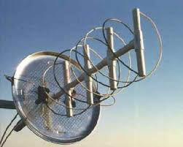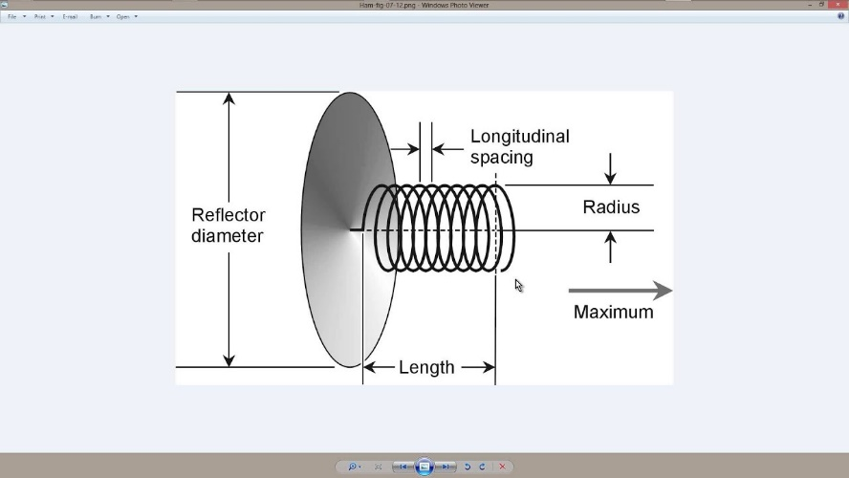

**Helical Antenna**

A helical antenna is a type of antenna that consists of a conducting wire wound in the shape of a helix. It is typically mounted over a ground plane and is used in various applications due to its unique characteristics, such as circular polarization and wide bandwidth. Here are some key features and concepts related to helical antennas:

**Key Features of Helical Antennas**

**Structure:**

* + The helical antenna is made by winding a conducting wire into a helix shape.
  + The helix is mounted perpendicularly on a ground plane.
  + The antenna can be made in either a right-hand or left-hand helical configuration, which determines the sense of polarization.

**Modes of Operation:**

* + **Normal Mode (Broadside Radiation):** In this mode, the antenna radiates perpendicular to the axis of the helix. This mode is used when the helix diameter and spacing between turns are small relative to the wavelength.
  + **Axial Mode (End-Fire Radiation):** In this mode, the antenna radiates along the axis of the helix. This mode is achieved when the helix diameter and spacing between turns are comparable to the wavelength. It is characterized by high gain and circular polarization.

**Polarization:**

* + Helical antennas produce circular polarization, which is beneficial in satellite and space communications because it reduces signal degradation due to atmospheric conditions.

**Bandwidth:**

* + Helical antennas have a wide bandwidth, making them suitable for applications where a wide range of frequencies is needed.

**Gain and Directivity:**

* + The gain of a helical antenna in the axial mode is relatively high, and the radiation pattern is highly directional along the axis of the helix.

**Applications of Helical Antennas**

* **Satellite Communications:** Due to their circular polarization and high gain, helical antennas are commonly used in satellite communication systems.
* **Space Probes and Deep Space Antennas:** The ability to maintain a stable link with ground stations makes helical antennas ideal for deep space missions.
* **Wireless Communication:** They are used in various wireless communication systems, including GPS and telemetry.
* **Aviation and Maritime:** Helical antennas are used in aviation and maritime applications for reliable communication.

**Design Parameters**

* **Helix Diameter (D):** The diameter of the helical winding.
* **Pitch (S):** The spacing between turns, also known as the axial length of one turn.
* **Number of Turns (N):** The total number of helical turns.
* **Wavelength (λ):** The operating wavelength of the antenna.
* **Pitch Angle (α):** The angle between the helix turns and the plane perpendicular to the axis of the helix.

The helical antenna's design and optimization involve adjusting these parameters to achieve the desired performance characteristics, which can be effectively simulated and analysed using tools like MATLAB.

**Software:**

**MATLAB**

**MATLAB** (short for "Matrix Laboratory") is a high-level programming language and environment designed primarily for numerical computing, data analysis, algorithm development, and visualization. It is widely used in engineering, science, and economics for tasks that require matrix manipulations, plotting of functions and data, implementation of algorithms, and interfacing with programs written in other languages.



Here are some key features and uses of MATLAB:

1. **Matrix and Array Computations**: MATLAB is designed to work with matrices and arrays, making it very efficient for mathematical computations.
2. **Data Visualization**: It provides extensive capabilities for data visualization, allowing users to create plots, graphs, and interactive data visualizations.
3. **Toolboxes**: MATLAB offers various specialized toolboxes for different applications, such as signal processing, image processing, control systems, and machine learning.
4. **Simulink**: A companion product to MATLAB, Simulink, is used for simulating dynamic systems and model-based design.
5. **Algorithm Development**: MATLAB is often used to develop and test algorithms before implementing them in other programming languages.
6. **Integration with Other Languages**: MATLAB can interface with programs written in C, C++, Java, and Python, allowing for flexibility in a multi-language environment.

**Design Specifications**

**Helix Design Specifications**

The helical antenna design specifications are as follows:

* Frequency range: 1.3 - 2 GHz
* Gain: 13 dBi +/- 1.5 dBi
* Axial Ratio: < 1.5

**Model Assumptions and Differences**

the helical antenna model available in the toolbox uses the following simplifying assumptions:

* **Conductor** - The original reference uses a cylinder of radius r while the toolbox uses a strip of width w.
* **Ground plane shape** - A square ground plane is used in the original reference, while the present toolbox model uses a circular shape.
* **Width of Feed** - The width of the feed in [2] is r/10 while the toolbox model uses w.
* **Design validation metric** - we will use the directivity since the simulated antenna has a negligibly small loss.

**Helix Design Parameters**

The helix model in the toolbox uses the strip approximation which relates the width of the strip to the radius of an equivalent cylinder [3]. In addition, the helix model in the toolbox has a circular ground plane. Choose the radius of the ground plane to be half the length of side of the square ground plane.

radius = 0.3e-3;

width = cylinder2strip(r);

feed height = 3*r;

Diameter = 56e-3;

radius = D/2;

turns = 17.5;

pitch = 11.2;

spacing = helixpitch2spacing (pitch, radius);

side = 600e-3;

radius GP = side/2;

**Frequency of Operation and Bandwidth**

The centre frequency is chosen as 1.65 GHz. A relative bandwidth of 45% is chosen which provides sufficient flexibility since the operating frequency limits result in a relative bandwidth of 42.5%. Relative bandwidth is calculated as,

fc = 1.65e9;

relative bandwidth = 0.45;

Band Width = relative BW*fc;

**Code:**

r = 0.3e-3;

width = cylinder2strip(r);

feedheight = 3*r;

D = 56e-3;

radius = D/2;

turns = 17.5;

pitch = 11.2;

spacing = helixpitch2spacing(pitch,radius);

side = 600e-3;

radiusGP = side/2;

fc = 1.65e9;

relativeBW = 0.45;

BW = relativeBW*fc;

hx = helix('Radius',radius,'Width',width,'Turns',turns,...

'Spacing',spacing,'GroundPlaneRadius',radiusGP,...

'FeedStubHeight',feedheight);

figure;

show(hx);

figure;

pattern(hx,fc);

Nf1 = 15;

Nf2 = 20;

fmin = 1.2e9;

fmax = 2.1e9;

fstep = 0.1e9;

fband1 = linspace(fmin,1.3e9,Nf1);

fband2 = linspace(fmin,fmax,Nf2);

freq = unique([fband1,fband2]);

Nf = length(freq);

D = nan(1,Nf);

f_eng = freq./1e9;

f_str = 'G';

fig1 = figure;

for i = 1:length(freq)

D(i) = pattern(hx,freq(i),0,90);

figure(fig1)

plot(f_eng,D,'x-')

grid on

axis([f_eng(1) f_eng(end) 9 16 ])

xlabel(['Frequency (' f_str 'Hz)'])

ylabel('Directivity (dBi)')

title('Peak Directivity Variation vs. Frequency')

drawnow

end

**Code Explanation**

**1.Helix Parameters Assigning**

r = 0.3e-3;

width = cylinder2strip(r);

feedheight = 3*r;

D = 56e-3;

radius = D/2;

turns = 17.5;

pitch = 11.2;

spacing = helixpitch2spacing(pitch,radius);

side = 600e-3;

radiusGP = side/2;

### **2.Frequency of Operation and Bandwidth**

fc = 1.65e9;

relativeBW = 0.45;

BW = relativeBW*fc;

**3.Creat Helical Antenna**

hx = helix('Radius',radius,'Width',width,'Turns',turns,...

'Spacing',spacing,'GroundPlaneRadius',radiusGP,...

'FeedStubHeight',feedheight);

figure;

show(hx);

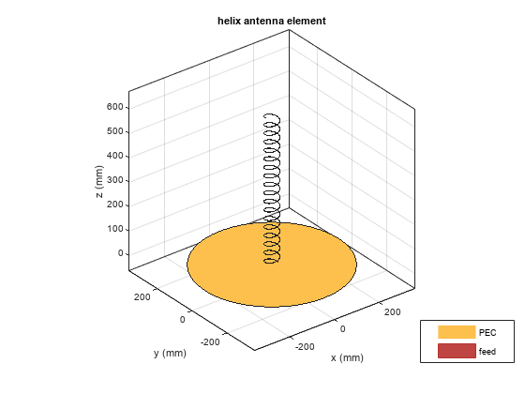

**4.Pattern Behaviour**

Plot the directivity radiation pattern of the helical antenna at the center frequency of 1.65 GHz. This pattern confirms the axial mode of operation for the helical antenna.

figure;

pattern(hx,fc);

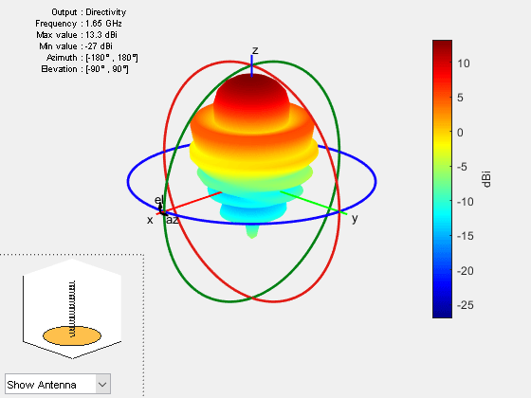

**To calculate the directivity variation of the main beam as a function of frequency:**

Nf1 = 15;

Nf2 = 20;

fmin = 1.2e9;

fmax = 2.1e9;

fstep = 0.1e9;

fband1 = linspace(fmin,1.3e9,Nf1);

fband2 = linspace(fmin,fmax,Nf2);

freq = unique([fband1,fband2]);

Nf = length(freq);

D = nan(1,Nf);

f_eng = freq./1e9;

f_str = 'G';

fig1 = figure;

for i = 1:length(freq)

D(i) = pattern(hx,freq(i),0,90);

figure(fig1)

plot(f_eng,D,'x-')

grid on

axis([f_eng(1) f_eng(end) 9 16 ])

xlabel(['Frequency (' f_str 'Hz)'])

ylabel('Directivity (dBi)')

title('Peak Directivity Variation vs. Frequency')

drawnow

end

